 Marking on it:  
TRULY MCG12864B1-3  
TR-803 94V-0  
CMS-CG042DGEW-N D0040  
They have EL Backlight. Some used from pos terminals some new  
They all working but there is no manual for them. So i have combined some info about them.  
They based on KS0107 and KS0108  chipset.

[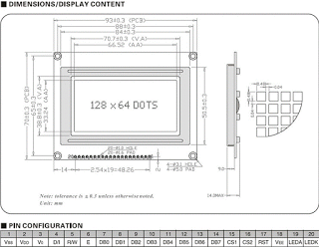](https://4.bp.blogspot.com/-4FVfzsQBgfc/WMrRecNi0AI/AAAAAAAAIXI/cu0DIs1cIBgrIiUp8ryKG-DKskWtltKRgCLcB/s1600/LCD128x64_physical.gif)

Pinout:

[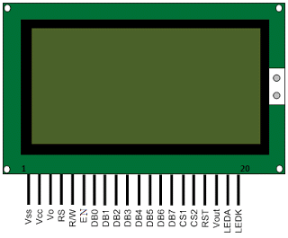](https://2.bp.blogspot.com/-7oP0tcUazyA/WMq9XPSfo6I/AAAAAAAAIWY/0m8M3ybNp80m-SZvHsBpPDfeDYRseaZ6gCLcB/s1600/Graphical+LCD+pin+diagram.gif)

|  |  |  |
| --- | --- | --- |
| Pin no. | **Function** | **Name** |
| 1 | Ground (0 V) | Vss |
| 2 | Supply voltage; 5V | Vcc |
| 3 | Contrast adjustment | Vo |
| 4 | High to display data; Low for instruction code | Register select (RS) |
| 5 | Low to write to the register; High to read from the register | Read/Write (R/W) |
| 6 | Reads data when high; Writes data at high to low transition (falling edge) | Enable (EN) |
| 7 | 8-bit data pins | DB0 |
| 8 | DB1 |
| 9 | DB2 |
| 10 | DB3 |
| 11 | DB4 |
| 12 | DB5 |
| 13 | DB6 |
| 14 | DB7 |
| 15 | Chip selection for IC1; Active high | CS1 |
| 16 | Chip selection for IC2; Active high | CS2 |
| 17 | Reset signal; Active low | RST |
| 18 | Output voltage for LCD driving | Vout |
| 19 | Backlight VCC (5V) | LED A |
| 20 | Backlight Ground (0V) | LED K |

 Photos: